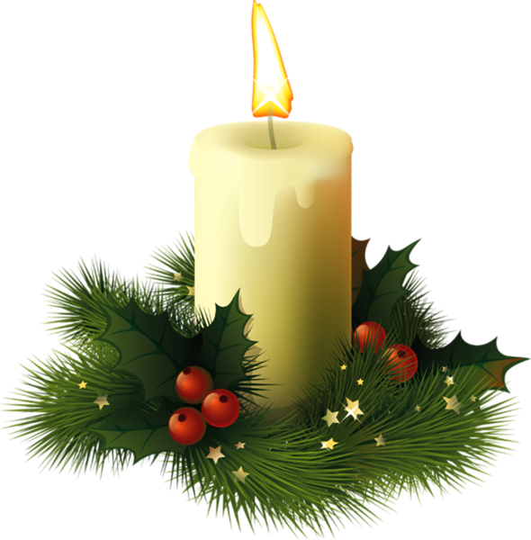
TOLSON’S CHAPEL

CHRISTMAS BY CANDLELIGHT
A Virtual Community
Christmas Celebration

“Tolson’s Chapel and School”
Facebook Live Event

Saturday
December 12, 2020
At 4:30pm

with special guests
Rev. John Schildt
Marian Gale, piano
Elyssa Doub, vocals

Due to COVID-19 restrictions, this is an online livestream event.
Please join us on our “Tolson’s Chapel and School” Facebook page!

More information at: tolsons.chapel@gmail.com

